

Dr. Sandra, Fox inc.
2020-07-24
Dr. Fox
95262 Leon Skyway Apt. 968, Dianeville, ME 21631
Phone: 4947949955
Fax: 7722986504

Re: Cynthia, Stokes
PHN: 7742181678
Birthdate: 05-Feb-1967
Address: 3790 John Rue Apt. 475, Patrickmouth, ND 42387
Patient number: 1120565492

To Whom It May Concern:

This is a medical letter to state the above patient is pregnant with expected delivery date of 29-May-2025. Hoping this information is satisfactory for your requirements.

Thank you.

Sincerely,
Dr. Sandra, Fox
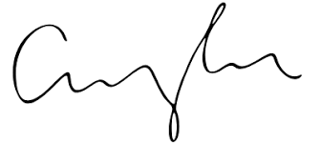
FRCS© NCMP
Clinical Assistant Professor, UBC
Department of Obstetrics and Gynecology SMH

